

Department of Psychology
Clinical Mental Health Counseling Program

Annual Program Evaluation Report
2024-2025

MCMHC Program Annual Program Evaluation Report
2024-2025
University Mission Statement
Indiana University Southeast is the regional campus of Indiana University that serves Southern Indiana and the Greater Louisville metropolitan area. As a public comprehensive university, IU Southeast provides high-quality programs and services that promote learning and prepare graduates for productive citizenship in a diverse society and contributes to the intellectual, cultural, civic, and economic development of our region.
Our faculty engage in research and creative activity that support teaching and learning and create opportunities for students to participate in applied learning. We are committed to constructive engagement in our local and regional community, marshaling our institutional and human capital toward the strengthening of our region as a place to work, build productive lives, and ensure the prosperity of future generations.
Master of Arts in Clinical Mental Health Counseling (MCMHC) Program Mission Statement
The mission of the Master of Arts in Clinical Mental Health Counseling is to prepare graduates with the knowledge and skills to become licensed mental health counselors. The Masters in Clinical Mental Health Counseling (MCMHC) Program prepares students to provide culturally sensitive services that address the holistic, developmental, and mental health needs of diverse populations. A primary goal of the Clinical Mental Health Counseling program is to graduate highly ethical and professional counselors with a dedication to counselor wellness and to the communities that they will serve. Faculty mentoring and a challenging counseling curriculum will prepare program graduates to become leaders in the counseling field through professional involvement, research, service, and advocacy.
The Goals of the MCMHC program are:
1. Provide a quality graduate level education in mental health counseling through the provision of a curriculum infused with critical thinking skills, multicultural competencies, ethics, and professionalism.
2. Prepare graduates to advocate for the needs of diverse people and work to promote social justice for the communities and individuals they serve.
3. Provide a practice-oriented program which provides an educational experience that encourages applied, theoretical knowledge while supporting students in the development of professional and clinical practice.
4. Foster an environment that educates and empowers professional counselors to become leaders and advocates for the profession and the greater community.
5. Provide an educational environment that upholds a wellness perspective and encourages wellness based personal and professional practices.
6. Provide specialized instruction, training, and supervision in clinical mental health counseling skills to prepare students to work in a variety of mental health settings.
The MCMHC program systematically gathers assessment data to evaluate if the program objectives are being met. Below is a map of how Broad Areas of Assessment that the program gathers information about that are related to both program objectives and student learning objectives.
MCMHC Program Assessment Area A: Professionalism, Advocacy, and Ethical Practices
SLO 1: Students will identify with the clinical mental health counseling profession, apply counseling ethics, and demonstrate a working knowledge of the history, theoretical concepts, advocacy, and practice skills required of entry level mental health counseling professionals.
MCMHC Program Assessment Area B: Theoretically based, Culturally Sensitive Clinical Practices
SLO 2: Students will demonstrate the ability to integrate knowledge of the theoretical models of counseling and multiculturally sensitive evidence-based interventions with professional practice skills to effectively counsel clients.
MCMHC Program Assessment Area C: Application of Assessment and Research Practices
SLO 3: Students will demonstrate the ability to apply assessment skills and counseling research evidence to provide effective counseling treatment.
MCMHC Program Assessment Area D: Wellness
SLO 4: Students will demonstrate the application of wellness concepts to professional counseling practice.
MCMHC Program Assessment Area E: Counseling and Helping Relationship
SLO 5: Students will demonstrate the counseling skills, counseling relationship development skills, the use of evidence-based practices, treatment plan development, and documentation skills expected of an entry-level counselor.

Program Objective | Area of Assessment | Student Learning Outcome | Program Implementation
1. Provide a quality graduate level education in mental health counseling through the provision of a curriculum infused with critical thinking skills, multicultural competencies, ethics, and professionalism. | Area A: Professionalism, Advocacy, and Ethical Practices | SLO 1: Students will identify with the clinical mental health counseling profession, apply counseling ethics, and demonstrate a working knowledge of the history, theoretical concepts, advocacy, and practice skills required of entry level mental health counseling professionals. | KPI 1.B  1.B-1: Advocacy Project Assignment  KPI CMHC 5.C.3  CMHC 5.C.3-A: Ethical Debate Paper
 | Area B: Theoretically based, Culturally Sensitive Clinical Practices | SLO 2: Students will demonstrate the ability to integrate knowledge of the theoretical models of counseling and multiculturally sensitive evidence-based interventions with professional practice skills to effectively counsel clients. | KPI 2.A  2.A-1: Cultural Immersion Experience assignment  2.A-2: Student Disposition form
 | Area C: Application of Assessment and Research Practices | SLO 3: Students will demonstrate the ability to apply assessment skills and counseling research evidence to provide effective counseling treatment. | KPI 8.B  8.B-1: Needs Assessment (Final Version)  8.B-2: Outcome Rating Scale (ORS) Assignment
2. Prepare graduates to advocate for the needs of diverse people and work to promote social justice for the communities and individuals they serve. | Area A: Professionalism, Advocacy, and Ethical Practices | SLO 1: Students will identify with the clinical mental health counseling profession, apply counseling ethics, and demonstrate a working knowledge of the history, theoretical concepts, advocacy, and practice skills required of entry level mental health counseling professionals. | KPI 1.B  1.B-1: Advocacy Project Assignment
 | Area B: Theoretically based, Culturally Sensitive Clinical Practices | SLO 2: Students will demonstrate the ability to integrate knowledge of the theoretical models of counseling and multiculturally sensitive evidence-based interventions with professional practice skills to effectively counsel clients. | KPI 2.A  2.A-1: Cultural Immersion Experience assignment  2.A-2: Student Disposition form  KPI 6.A  6.A-1: Group Proposal  6.B-2: Group Critique
3. Provide a practice-oriented program which provides an educational experience that encourages applied, theoretical knowledge while supporting students in the development of professional and clinical practice. | Area B: Theoretically based, Culturally Sensitive Clinical Practices | SLO 2: Students will demonstrate the ability to integrate knowledge of the theoretical models of counseling and multiculturally sensitive evidence-based interventions with professional practice skills to effectively counsel clients. | KPI 4.A  4.A-1: Career Information assignment (visit career center) - effective Fall 2025  4.A-2: Career Genogram assignment  4.A-2:Career Development Self-Reflection assignment
 | Area C: Application of Assessment and Research Practices | SLO 3: Students will demonstrate the ability to apply assessment skills and counseling research evidence to provide effective counseling treatment. | KPI 7.A  7.A-1: Case vignettes  7.A-2: Case conceptualization  KPI 8.A  8.A-1: Mini Proposal Assignment  8.A-2: Case Conceptualization
4. Foster an environment that educates and empowers professional counselors to become leaders and advocates for the profession and the greater community. | Area A: Professionalism, Advocacy, and Ethical Practices | SLO 1: Students will identify with the clinical mental health counseling profession, apply counseling ethics, and demonstrate a working knowledge of the history, theoretical concepts, advocacy, and practice skills required of entry level mental health counseling professionals. | KPI 1.B  1.B-2: Professional Advocacy Paper
5. Provide an educational environment that upholds a wellness perspective and encourages wellness based personal and professional practices. | Area D: Wellness | SLO 4: Students will demonstrate the application of wellness concepts to professional counseling practice. | KPI 1.A  1.A-1 - Ethics Final Exam #49  KPI 1.A-2 – Wellness Plan (Internship I)
6. Provide specialized instruction, training, and supervision in clinical mental health counseling skills to prepare students to work in a variety of mental health settings. | Area E: Counseling and Helping Relationship | SLO 5: Students will demonstrate the counseling skills, counseling relationship development skills, the use of evidence-based practices, treatment plan development, and documentation skills expected of an entry-level counselor. | KPI 3.A  3.A-1: Human Development Research Paper  3.A-2: Case Conceptualization Assignment  KPI 5.A  5.A-1: Skills Practice & Analysis assignment  5.A-2: Site Supervisor/Faculty Supervisor Final Evaluation (CCS-R Part 1)  KPI CMHC 5.C.5:  CMHC 5.C.5-A: Final site supervisor eval (Internship 1)  CMHC 5.C.5-B: Final site supervisor eval (Internship 2)

Program Vital Statistics
Program Graduates
2023 Graduates | 2024 Graduates
17 | 12

In 2023 and 2024, the MCMHC program graduated 17 students and 12 students, respectively. There was some attrition in Cohort 2022 that resulted in a lower number of students graduating in 2024 than in previous years. The program anticipates 15 graduates in August 2025.
Follow-up surveys of program graduates and faculty monitoring of graduates indicate that 100% of MCMHC program graduates are either enrolled in a doctoral program or are employed at least part time as a mental health counselor.

Program Enrollment
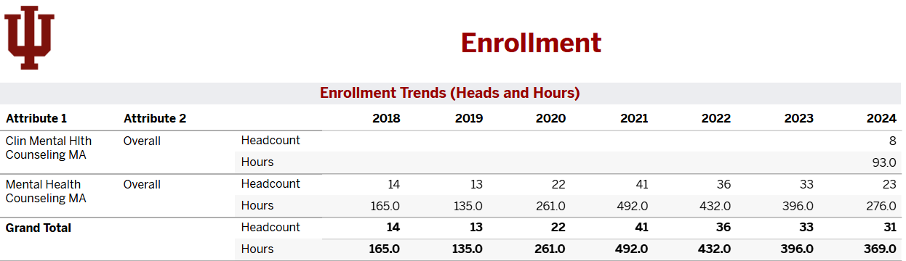
Present and historical program enrollment data for fall semesters is provided. Enrollment in Fall 2024 was comparable to Fall 2023. Enrollment data suggests that the MCMHC program is a healthy program that maintains consistent student enrollment. Demand for the MCMHC program continues to be high as community mental health needs continue to be underserved.
Program Headcount and Credit Hour Trends
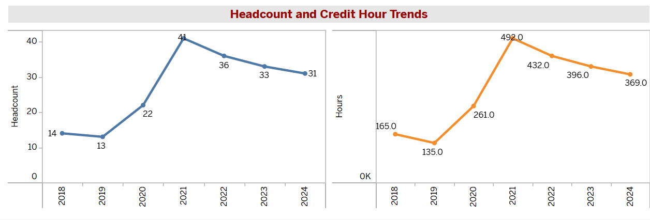

Program Enrollment and Student Characteristics
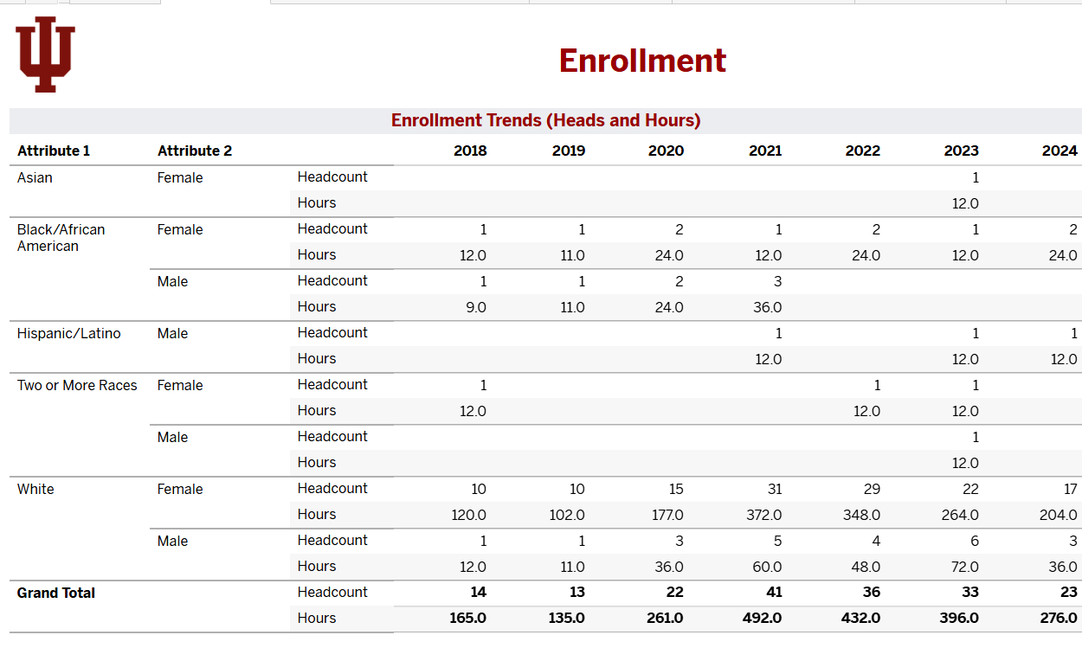
Cohort 2023 is 75% female and 24% male while Cohort 2024 is 82% female and 17% male. Student composition of Cohort 2023 is 3% Asian, 3% Black/African American, 3% Hispanic/Latine, 6% Two or more, and 84% White. Comparatively, Cohort 2024 is 8% Black/African American, 4% Hispanic/Latine and 86% White.
Program Applications and Acceptance Rate
Program Applications | 37
Applicants Admitted | 31
Acceptance Rate | 84%

Eighty four percent of applicants who applied to the MCMHC for the Fall 2024 cohort were admitted to the program. Not all applicants who were offered admission accepted the offer to enroll in the MCMHC program.
Program Completion Rate
Program Completion Rate
Cohort 2022 | 40%
Cohort 2023 | 81%
Program completion rates for Cohort 2022 and Cohort 2023 were 40% and 81% respectively. The program retention rate was significantly lower for Cohort 2022 than for the previous year’s cohort and Cohort 2023. Attrition was high for Cohort 2022. Anecdotal information from the students who withdrew was that they withdrew due to either personal or financial reasons. Faculty have taken steps to curb this trend which appears to be working as the completion rate has increased to 81% for Cohort 2023. Faculty instituted additional advisement during vulnerable periods within the program where students may withdraw. Additionally, faculty made efforts to increase students’ awareness of support resources and encouraged them to use the resources available.
Program Credentialing Rate
Graduate Credentialing Rate
2023 Graduates  2024 Graduates | 81%
2023 Graduates  2024 Graduates | 88%

MCMHC program students are successfully completing the National Counselor Exam (NCE) which is the initial licensing exam required by the state of Indiana for which the program has data. Data on the credentialing rate of program graduates is determined from the Indiana Behavioral Health Licensing Board’s online licensing database. Data for graduates’ licensure in states other than Indiana is not available.
2024 Employer Survey
Employers of MCMHC graduates are surveyed each year in August. Employers are sent a Qualtrics survey in which they are asked questions about program graduates that reflect the program objectives. In 2024, five surveys were returned. Program graduates were rated as average to above average on all skill and knowledge areas employers expect new professionals to have to provide services effectively. Additionally, employers rated program graduates as equally or better prepared than graduates of other programs that they employ.
Employer Survey | Above Average | Average
- MCMHC program graduates’ knowledge of the roles and functions of the profession | 60% | 40%
- MCMHC program graduates’ knowledge and skill to apply agency policy and procedures | 40% | 40%
- MCMHC program graduates’ knowledge and skills to maintain appropriate professional boundaries | 60% | 20%
- MCMHC program graduates’ knowledge and skills to make ethical and professional decisions | 60% | 20%
- MCMHC program graduates’ knowledge and skills to appropriately apply counseling theory to client concerns and to determine treatment outcomes | 40% | 40%
- MCMHC program graduates’ knowledge and skills necessary to conduct biopsychosocial or initial assessments | 80% | 20%
- MCMHC program graduates’ knowledge and skills to accurately diagnose clients | 80% | 20%
- MCMHC program graduates’ knowledge and skills necessary to write and prepare effective documentation and treatment plans | 40% | 40%
- MCMHC program graduates’ knowledge and skills to effectively advocate for clients | 80% | 20%
- MCMHC program graduates’ knowledge and skills to effectively respond to multicultural and discrimination issues | 80% | 20%
- MCMHC program graduates’ knowledge and skills necessary to interview and communicate with clients | 60% | 40%
- MCMHC program graduates’ knowledge and ability to effectively interact with staff and supervisors | 60% | 40%
- MCMHC program graduates’ knowledge and skills necessary for effective community relations | 20% | 60%
- Compare the preparation of MCMHC graduates to other personnel or graduates at the same level | 40% (Better prepared) | 40% (About equivalent)
N=5

Program Graduates Survey 2024
MCMHC program graduates are surveyed in August. Graduates are sent a Qualtrics survey that asks about their preparation to be an entry level clinical mental health counselor and employment information. The survey questions reflect the program objectives. In 2024, 10 graduates completed the annual survey. Results from the survey indicate that program graduates feel that the program adequately prepared them for entry level counseling work.
2024 Graduates Survey | Strongly Agree | Agree
- The MCMHC program prepared me for the roles and functions of the profession | 20% | 70%
- The MCMHC program prepared me to apply agency policy and procedures | 20% | 70%
- The MCMHC program prepared me with the knowledge and skills to maintain appropriate professional boundaries | 50% | 30%
- The MCMHC program prepared me with knowledge and skills to make ethical and professional decisions | 30% | 60%
- The MCMHC program prepared me with the knowledge and skills to appropriately apply counseling theory to client concerns and to determine treatment outcomes | 30% | 50%
- The MCMHC program prepared me with the knowledge and skills necessary to conduct biopsychosocial or initial assessments | 60% | 20%
- The MCMHC program prepared me with the knowledge and skills to accurately diagnose clients | 30% | 40%
- The MCMHC program prepared me with the knowledge and skills necessary to write and prepare effective documentation and treatment plans | 50% | 30%
- The MCMHC program prepared me with the knowledge and skills to effectively advocate for clients | 50% | 40%
- The MCMHC program prepared me with the knowledge and skills to effectively respond to multicultural and discrimination issues | 50% | 50%
- The MCMHC program prepared me with the knowledge and skills necessary to interview and communicate with clients | 50% | 40%
- The MCMHC program prepared me with the knowledge and ability to effectively interact with staff and supervisors | 50% | 40%
- MCMHC program prepared me with the knowledge and skills necessary for effective community relations | 40% | 40%
N=10

Key Performance Indicator Aggregate Data
Program cohort students are assessed on program key performance indicators (KPIs) throughout the program. These KPIs are reflective of the CACREP eight content areas and CMHC specialty areas that students must show knowledge and skill proficiency in by the time that they graduate from the MCMHC program. Additionally, the KPIs also help program administration determine if the program objectives are being successfully met. KPIs are assessed at two points during the program, with one time being during students’ clinical experience—practicum or their first or second internship as mandated by CACREP.
KPI data for Cohort 2024 show that students showed proficiency in all program KPIs except for one—5.C-A-1 which reflects application of the code of ethics to client cases. The faculty has determined that the assignment used to assess this KPI requires revision of the rubric to ensure that student performance on this KPI is accurately reflected. The remaining KPIs for Cohort 2024 will be assessed during the 2025-2026 assessment cycle. There were four students who were determined to have not met KPI CMHC 5.C-A. Faculty have worked with each student to assist them with building there knowledge in this area so that they can show proficiency when they are assessed at Time 2.
Cohort 2023 KPI data indicates that students showed proficiency in all program KPIs except for 5.A-1, 7.A-2 and 8.A-2. KPI 5.A-1 assesses students’ skill in developing a therapeutic relationship with clients. KPI 7.A-2 assessed students’ skill in the use of assessments to inform client treatment. KPI 8.A-2 assessed students’ knowledge and skill in the use of research to inform their counseling practice. It should be noted that data for KPI 5.A-1 was collected prior to the change made to the COUN C601 course, making it a 15-week course. The course now specifically addresses students’ micro-counseling skills. Cohort 2024 students met this KPI 100% as they took the course in the new format. This suggests this change has had a positive impact on this skill area.
The remaining KPIs that were not met by this cohort were associated with the content areas of assessment and research. While previous cohorts met assessment benchmarks for assessment, this cohort did not. However, cohorts not meeting assessment benchmarks for research has been a trend that was seen in previous assessment cycles. As a result, faculty plan to continue to make programmatic and curricular changes to improve performance in this area.

Cohort 24
Fall 2024-Summer 2025
Cohort 2024 (First Year Cohort)
Fall 2024 | Data Collection | KPI Assessment | Results
1.A-1: Identify self-care strategies appropriate to the counselor role | Time 1 Fall 2024 | COUN C511 Ethics Final exam Item 49 | 100% met
1.B-1: Students will apply knowledge of the role and process of the professional counselor advocating on behalf of the profession and clients. | Time 1 Fall 2024 | COUN C563 Advocacy Project | 100% met
2.A-1: Students will cultivate the integration of multicultural knowledge and social justice competencies with professional practice skills. | Time 1 Spring 2025 | COUN C501 Cultural Immersion Experience | 100% met
5.A-1: Students will demonstrate fundamental counseling skills and the ability to develop therapeutic relationships with clients. | Time 1 Spring 2025 | COUN C601 Skills Practice & Analysis assignment | 100% met
6.A-1: Design a culturally relevant group for implementation in a CMHC setting | Time 1 Spring 2025 | COUN C532 Group Counseling Proposal | 100% met
7.A-1: Students will use assessments to inform the diagnostic and treatment-planning processes. | Time 1 Fall 2024 | COUN C624 Case Vignette | 100% met
CMHC 5.C.3-A: Students will demonstrate the application of ethical codes, legislation, and policy on specific client cases. | Time 1 Fall 2024 | COUN C511 Ethical Debate Paper | 75% met  25% not met (n=4)
Cohort 23
Fall 2023-Summer 2025
Cohort 2023 (Year Two Cohort)
Key Performance Indicators | Data Collection | KPI Assessment | Results
1.A-1: Identify self-care strategies appropriate to the counselor role | Time 1 F24 | COUN C511 Ethics Final exam Item 49 (New F24) | 100% met
1.A-2: Identify self-care strategies appropriate to the counselor role | Time 2 Sp25 | COUN C550-1 Wellness Plan | 100% met
1.B-1: Students will apply knowledge of the role and process of the professional counselor advocating on behalf of the profession and clients. | Time 1 Fall 2023 | COUN C563 Advocacy Project | 95% met
1.B-2: Students will apply knowledge of the role and process of the professional counselor advocating on behalf of the profession and clients. | Time 2 Su25 | COUN C550-2 Professional Advocacy Paper (NEW) | 100% met
2.A-1: Students will cultivate the integration of multicultural knowledge and social justice competencies with professional practice skills. | Time 1 Spring 2024 | COUN C501 Cultural Immersion Experience | 99% met
2.A-2: Students will cultivate the integration of multicultural knowledge and social justice competencies with professional practice skills. | Time 2 Spring 2025 | COUN C550-1 Student Disposition Form | 87% met  (n=2)
3.A-1 Students will identify systemic and environmental factors that affect human development, functioning, and behavior | Time 1 Fall 2024 | COUN C514 search Paper | 100% met
3.A-2: Students will identify systemic and environmental factors that affect human development, functioning, and behavior | Time 2 Spring 2025 | COUN C550-1 | 100% met
4.A-1. Students will apply career development theory to counseling practice | Time 1 Summer 2025 | COUN C552 Career Genogram assignment | 100% met
4.A-2. Students will apply career development theory to counseling practice | Time 2 Summer 2025 | COUN C550-2 Career Development Self-Reflection | 100% met
5.A-1 Students will demonstrate fundamental counseling skills and the ability to develop therapeutic relationships with clients. | Time 1 Spring 2024 | COUN C601 Skills Practice & Analysis assignment | 65% met  35% not met (n=6)
5.A-2 Students will demonstrate fundamental counseling skills and the ability to develop therapeutic relationships. | Time 2 Fall 2024 | COUN C524 Site Supervisor Final Evaluation (CCS-R) | 88% met  12% not met(n=2)
6.A-1: Design a culturally relevant group for implementation in a CMHC setting | Time 1 Spring 2024 | COUN C532 Group Counseling Proposal | 99% met
6.A-2: Design a culturally relevant group for implementation in a CMHC setting | Time 2 Sum 2025 | COUN C550-2 Group Reflection Paper | 100% met
7.A-1: Students will use assessments to inform the diagnostic and treatment-planning processes. | Time 1 Fall 2024 | COUN C624 Case Vignette | 99% met
7.A-2: Students will use assessments to inform the diagnostic and treatment-planning processes. | Time 2 Spring 2025 | COUN C550-1  Case Conceptualization | 78% met  22% not met (n=3)
8.A-1 Students will demonstrate the ability to use research to inform counseling practice | Time 1 Fall 2024 | COUN C520 Mini Proposal Assignment | 80% met  20% not met (n-3)
8.A-2 Students will demonstrate the ability to use research to inform counseling practice | Time 2 Spring 2025 | COUN C550-1 Case Conceptualization | 65% met  35% not met (n=5)
8.B-1: Students will demonstrate the ability to evaluate counseling interventions and programs | Time 1 Fall 2025 | COUN C534 Clinical Practicum  Outcome Rating Scale (ORS)  Assessment of this KPI with this assignment  was not implemented in F24, implementation will begin in F25 | No data available
8.B-2: Students will demonstrate the ability to evaluate counseling interventions and programs | Time 2 Spring 2024 | COUN C537 Final Needs Assessment | 100% met
CMHC 5.C.3-A: Students will demonstrate the application of ethical codes, legislation, and policy on specific client cases. | Time 1 Fall 2024 | COUN C511 Ethical Debate Paper | 85% met  15% not met (n=2)
CMHC 5.C.3-B: Students will demonstrate the application of ethical codes, legislation, and policy on specific client cases. | Time 2 Spring 2025 | COUN C550-1 Ethical Reflection | 99% met

Program objectives are assessed through Broad Areas of Assessment which program faculty has determined are tied to specific student learning objectives, program KPIs, and program surveys. The table below details which program objectives have been fully met, partially met or not met.

Program Objective | Area of Assessment | Student Learning Objectives | Program Objective Assessment Outcome
1. Provide a quality graduate level education in mental health counseling through the provision of a curriculum infused with critical thinking skills, multicultural competencies, ethics, and professionalism. | Area A: Professionalism, Advocacy, and Ethical Practices | SLO 1: Students will identify with the clinical mental health counseling profession, apply counseling ethics, and demonstrate a working knowledge of the history, theoretical concepts, advocacy, and practice skills required of entry level mental health counseling professionals. | Objective partially met
 | Area B: Theoretically based, Culturally Sensitive Clinical Practices | SLO 2: Students will demonstrate the ability to integrate knowledge of the theoretical models of counseling and multiculturally sensitive evidence-based interventions with professional practice skills to effectively counsel clients. | Objective Met
 | Area C: Application of Assessment and Research Practices | SLO 3: Students will demonstrate the ability to apply assessment skills and counseling research evidence to provide effective counseling treatment. | Objective Not Met
2. Prepare graduates to advocate for the needs of diverse people and work to promote social justice for the communities and individuals they serve. | Area A: Professionalism, Advocacy, and Ethical Practices | SLO 1: Students will identify with the clinical mental health counseling profession, apply counseling ethics, and demonstrate a working knowledge of the history, theoretical concepts, advocacy, and practice skills required of entry level mental health counseling professionals. | Objective Partially Met
 | Area B: Theoretically based, Culturally Sensitive Clinical Practices | SLO 2: Students will demonstrate the ability to integrate knowledge of the theoretical models of counseling and multiculturally sensitive evidence-based interventions with professional practice skills to effectively counsel clients. | Program Objective Met
3. Provide a practice-oriented program which provides an educational experience that encourages applied, theoretical knowledge while supporting students in the development of professional and clinical practice. | Area B: Theoretically based, Culturally Sensitive Clinical Practices | SLO 2: Students will demonstrate the ability to integrate knowledge of the theoretical models of counseling and multiculturally sensitive evidence-based interventions with professional practice skills to effectively counsel clients. | Program Objective Met
 | Area C: Application of Assessment and Research Practices | SLO 3: Students will demonstrate the ability to apply assessment skills and counseling research evidence to provide effective counseling treatment. | Objective Not Met
4. Foster an environment that educates and empowers professional counselors to become leaders and advocates for the profession and the greater community. | Area A: Professionalism, Advocacy, and Ethical Practices | SLO 1: Students will identify with the clinical mental health counseling profession, apply counseling ethics, and demonstrate a working knowledge of the history, theoretical concepts, advocacy, and practice skills required of entry level mental health counseling professionals. | Objective Partially Met
5. Provide an educational environment that upholds a wellness perspective and encourages wellness based personal and professional practices. | Area D: Wellness | SLO 4: Students will demonstrate the application of wellness concepts to professional counseling practice. | Program Objective Met
6. Provide specialized instruction, training, and supervision in clinical mental health counseling skills to prepare students to work in a variety of mental health settings. | Area E: Counseling and Helping Relationship | SLO 5: Students will demonstrate the counseling skills, counseling relationship development skills, the use of evidence-based practices, treatment plan development, and documentation skills expected of an entry-level counselor. | Program Objective Met

Analysis of KPI and Survey Data
Data for program Cohort 2023 and Cohort 2024 are included in this annual report due to the identification of Key Performance Indicators which had not been assessed as KPIs in previous assessment reports. Reviewing data from more than one cohort in time allows the MCMHC program faculty to determine if programmatic changes are required to improve student performance on the identified KPIs. The KPIs were developed based on assignments that were already being assigned in program courses for the last several years. Having collected data from more than one point in the program, the faculty was able to determine trends that indicated that programmatic or curricular changes are required to address deficiencies in content or skill as evidenced by results of the assessment of KPIs for Cohort 2023 and Cohort 2024. Additionally, the faculty has been able to determine if any KPIs need revision to better assess student performance.
Analysis of program KPIs has confirmed program assessment data from previous years. Data from this assessment cycle continues to indicate that students need further support in the content area of research. Results from the analysis of KPI 8.A-1 and 8.A-2 which assess students’ research skills showed only 65% of students met that KPI. At time one only 80% of students met the KPI. While 80% showing proficiency does meet the program benchmark, it still suggests that research continues to be a weak area for program students. As a result of this data trend, faculty has determined that further programmatic changes are needed to improve students’ research skills. A second KPI for which students did not meet the program benchmark was KPI 5.A-1, which assesses students’ ability to develop a therapeutic relationship with clients. Only 65% of Cohort 2023 students met the KPI benchmark at time one. Previous assessment cycles had shown students were not consistently strong in their counseling skills, particularly during their first skills classes. As a result of this and previous cohort data, faculty determined the need to make COUN C601 Counseling Techniques: Humanistic Interventions course a 15-week course and offer it during the spring semester when students were also taking COUN C532 Introduction to Group Counseling. This would allow students additional time to develop their counseling micro skills and demonstrate initial competence in the development of a therapeutic relationship with clients. In Spring 2025, Cohort 2024 was the first cohort to take the course in the 15-week format. Data from Cohort 2024 suggests the programmatic change was successful as 100% of Cohort 2024 students met the time one benchmark for KPI 5.A-1. Faculty will determine if this trend continues at time two assessment of KPI 5.A, which will occur in C-550-2 Internship 2, Spring 2026.

Two additional KPIs were not met by 80% of program students—an outcome not observed in previous cohorts. KPI 7.A-2, which measures student competency in the use of assessments to inform their diagnosis of clients and their treatment planning, was only met by 78% of Cohort 2023 students at time two. Faculty initiated remediation efforts for those students who did not show proficiency in the KPI at time two. The faculty will need to determine if this trend continues for Cohort 2024, requiring further curricular or programmatic changes. Cohort 2024 will be assessed on this KPI in Fall 2025. The second KPI, KPI 5.3-1, which addresses students’ ability to apply ethical codes to client cases, was only met by 78% of students in Cohort 2024. Advisors and instructors will work with students who did not meet this KPI at time one to ensure that they meet it at time two. This result suggests that this KPI may need to be evaluated to determine if it accurately assesses students’ knowledge to apply the ACA ethical code to client cases.
Program objectives were also assessed during the assessment cycle. The program’s broad areas of assessment reflect the program’s objectives (See Program Objectives Assessment table, pg. 17). Broad Area of Assessment A was partially met during this assessment cycle. Broad Area of Assessment B was met. Broad Area of Assessment C was not met during this assessment cycle. Broad Area of Assessment D was met as was Broad Area of Assessment E.
Surveys of program graduates indicate that graduates overwhelmingly feel that the program adequately prepared them for a career as a mental health counselor. Eighty percent of MCMHC program students who responded to the surveyed felt that they were adequately prepared for their career as a mental health counselor. The MCMHC program was rated lowest by graduates in its preparation for diagnosing clients. Faculty will consider this feedback in terms of strengthening the skills students learn in COUN C624 Principles of Psychopathology to improve student confidence in diagnosis.
Employer surveys were also positive regarding MCMHC graduates. MCMHC program students were rated as Average to Above Average on the skills of knowledge of the roles and functions of the profession, ability to conduct biopsychosocial assessments, diagnosis, advocacy and multicultural counseling skills. These are areas that are related to both program KPIs and to the objectives or the MCMHC program. Eighty percent of employers of MCMHC graduates rated them as equivalent to better prepared than graduates from other programs at a similar level.
Program Changes
At the faculty annual assessment meeting held in May 2025, faculty reviewed the assessment results discussed in this report. As a result of this data and anecdotal data provided by program students, faculty identified programmatic or instructional changes needed to address program objectives that were not met, or only partially met and KPIs that required revision.
The following specific program changes were identified and will be implemented in the 2025-2026 academic year, as noted in the Plan of Action:
- Adding a crisis course
  - Anecdotal data from students during practicum/internship indicated that students are regularly discussing high acuity clients and the expectation that they regularly assess for risk; contacting DCS; using trauma-informed approaches. Additionally, data from first year cohort students indicate that students are working with suicidal clients as case workers or in other capacities. Based on this data and in order to better support CACREP 2016 standards and the program’s transition to CACREP 2024 standards, the faculty has determined that a crisis class needs to be added to the program plan of study so that students are better prepared and feel more confident in their response to clients in crisis.
- Eliminating COUN C540 Principles of Assessment and Prediction course
  - In order to offer the proposed crisis course and to reduce content redundancy, faculty have determined that the COUN C540 course will be deleted from the MCMHC plan of study.
- Move COUN C552 Career Counseling and Development course from Summer 1 to Spring for Cohort Year 2 students.
  - COUN C552 will be moved to the Spring semester of Year 2 because this will allow students to have the career counseling knowledge they will need to take the NCE early, since Indiana now offers this option. Previously, Career Counseling was offered in either Summer 1 or Summer 2, which was not early enough for students to have completed the course prior to taking the exam.
  - Many program students are working with adolescents and young adults in their internship who could benefit from career counseling. By offering the course in a 15-week format, students will gain sufficient knowledge to incorporate this knowledge into their counseling practice with middle school and high school students.

- COUN C520 Research in Counseling will be offered in a hybrid rather than asynchronous online format. Data from KPI 8.A1 and 8.A2 indicate that research is a content area of weakness for program students. Historically, research is often a content area that students often find challenging on the NCE. Additionally, students have reported that they would prefer that this course be offered in-person rather than it being offered asynchronously online. By offering the course in a hybrid format this will allow students to gain additional in-person contact with the course instructor which will help students to receive assistance with learning research concepts that are difficult for students who are practitioners to grasp.
- COUN C601 was moved to a 15-week semester to improve performance on KPI 5.A1. This will allow students more time to develop counseling micro skills and conceptualization skills. Initial data appear to support this change in course format.
- Data from KPI 5.C.3-1 suggests that changes are needed to the KPI that measures application of the code of ethics and policy to client cases. Presently, this is assessed by the Ethical Debate paper in the Fall during the COUN C511 Professional Issues and Ethics course.
  - A second KPI was developed to further assess students’ knowledge and skill in the application of the code of ethics and ethical decision making during the second year in internship. This KPI was collected initially in Spring 2025. Data for Cohort 2024 will be collected in Spring 2026.
- KPI 7A.2 data suggests students need more practice with using assessments to inform the diagnosis of clients and their treatment planning.
  - A new KPI was developed to assess students’ knowledge and skill in their use of assessments. In Fall 2025, Cohort 2024 will be assessed initially in COUN C524 Clinical Practicum with the use of the Outcome Rating Scale assignment. Students will be assessed a second time in COUN C537 Program Evaluation.

Program Plan of Action
The MCMHC program will enact the following plan during the 2025-2026 academic year to address the KPIs and program objectives that were not met during the previous assessment cycle. Data collected during the next assessment cycle will show if these changes have resulted in an improvement in students’ performance.
- Fall 2025
  - COUN C520 Research in Counseling is being offered in hybrid format to increase students’ face to face contact to improve student performance on KPI 8.A.1 and 8.A.2
  - COUN C520 Research in Counseling content has been revised in anticipation of the 2026-2027 academic year in which this course will also include the content previously covered in COUN C537 Program Evaluation.
  - KPI 5.C.A-1 has been revised to ensure that it assesses students’ skills and knowledge in the application of the code of ethics.
  - KPI 7.A-1 is being assessed with a new KPI during COUN C524. This has become the time one assessment point for this KPI. KPI 7.A-2 will be assessed in COUN C550 Internship which will be time two assessment of this KPI.
  - COUN C669 Assessment in Counseling cours has been revised to include content from COUN C540 Principles of Assessment and Prediction
  - Revision of current employer survey to include an option for employers that are also site supervisors to gain site supervisor specific data about the MCMHC program.
  - Program faculty will submit paperwork for approval by the Indiana University Southeast Academic Policies Committee for approval of the following program course and plan of study changes: The Indiana University Southeast Academic Policies Committee and the Indiana University Southeast Faculty Senate approved these changes in September 2025.
    - COUN C552 Career Counseling and Development moved to 15-week spring semester beginning Spring 2026.
    - COUN C537 Program Evaluation will be removed from the program plan of study. Course content will be covered in COUN C520 Research in Counseling.
    - COUN C540 Principles of Assessment and Prediction will be removed from the program plan of study. Content from this course will be covered in COUN C669 Assessment in Counseling.
    - COUN C624 Principles of Psychopathology will be renamed as COUN C 625 Etiology and Diagnosis of Mental Health Disorders to use more current terminology.
    - COUN C736 Child Psychopathology will be revised to COUN C737 Counseling Children and Adolescents. This course will cover counseling interventions and counseling skills required to work with children and adolescents.
    - COUN C601 Counseling Techniques: Humanistic Interventions renamed COUN C602 Counseling Skills and Techniques.
    - Program will add a Crisis Counseling course (COUN C564) to replace COUN C537 Program Evaluation offered in the spring semester of Year 2.
    - Program will add COUN C738 Contemporary Issues in Counseling which will be offered in Summer of Year 2. This course will teach current topics in the field so course content will vary based on the focus of the course each semester.

- Spring 2026
  - COUN C552 Career Counseling and Development will be offered in the spring semester of Year 2.
  - Faculty will meet in May to review assessment data and determine data trends and to determine changes are needed in program KPIs.
  - Faculty will continue to ensure that CACREP standards are being met in all program courses.
  - Faculty will review program courses to ensure that all CACREP 2024 content standards are covered.

